**Course 12 Specialist Test 3 & Investigation 2**

Test mark ______/24 Investigation mark ______/14

Student name: ________________ Teacher name: ________________

**Task type: Response/Investigation**

**Time allowed for this task: 45 mins**

**Number of questions: 6 questions Test/ 1 question Inv**

**Materials required:** Calculator with CAS capability (to be provided by the student)

Standard items: Pens (blue/black preferred), pencils (including coloured), sharpener, correction fluid/tape, eraser, ruler, highlighters

Special items: Drawing instruments, templates, notes on one unfolded sheet of   
A4 paper, and up to three calculators approved for use in the WACE examinations

**Marks available: 24 marks Test/ 17 marks Inv**

**Task weighting: Test 6 % Inv 8%**

**Formula sheet provided: Yes**

**Note: All part questions worth more than 2 marks require working to obtain full marks.**

This first section will be recorded as test 3 in the assessment schedule.

Students decide how much time they will spend on each section, recommended 25 mins test & 20 mins Inv.

Q1 (3 marks)

Determine the equation of the tangent to  at the point .

|  |
| --- |
| **Solution** |
|  |
| **Specific behaviours** |
| 🗸 uses implicit diff using both quotient and product rules  🗸 determines dy/dx  🗸 states equation of tangent |

Q2 (3 marks)

If  determine an expression for  in terms of .

|  |
| --- |
| **Solution** |
|  |
| **Specific behaviours** |
| 🗸 uses product rule & implicit diff  🗸 subs dy/dx  🗸 obtains correct expression |

Q3 (2 & 3 = 5 marks)

If  and  determine:

1.  in terms of .

|  |
| --- |
| **Solution** |
|  |
| **Specific behaviours** |
| 🗸 determines rates of x and y in terms of t  🗸 determines dy/dx in terms of t |

1.  in terms of .(No need to simplify)

|  |
| --- |
| **Solution** |
|  |
| **Specific behaviours** |
| 🗸 attempts to diff dy/dx wrt to t  🗸 uses quotient rule correctly  🗸 divides by dx/dt |

Q4 (4 marks)

Consider a metal sphere where the volume was measured and found to have an error of 5%. Use increments formula to determine the approximate percentage error in the radius.

|  |
| --- |
| **Solution** |
|  |
| **Specific behaviours** |
| 🗸 uses increments formula  🗸 derives expression for %V  🗸 simplify in terms of %r  🗸 gives approx. % change |

Q5 (4 marks)

Consider a triangle with angle  radians and opposite side length  cm, see diagram below. If the angle is changing at a rate of 3 radians/second, determine the exact rate of change of , when .

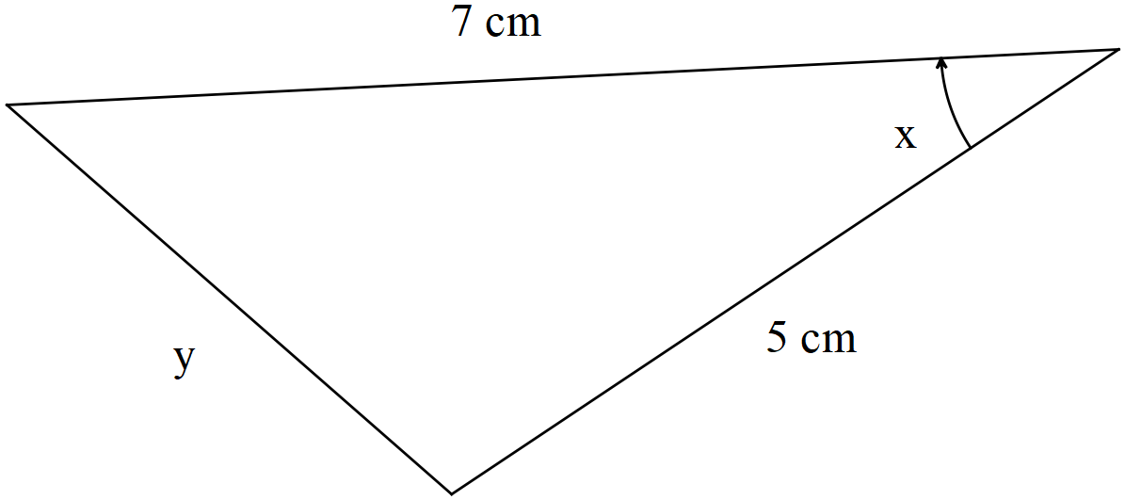

|  |
| --- |
| **Solution** |
|  |
| **Specific behaviours** |
| 🗸 uses cosine rule  🗸 solves for y  🗸 obtains equation for time rates of x and y  🗸 determines exact expression for y rate |

Q6 (5 marks)

Consider a car moving at metres/second towards a brick wall. On top of the car is a rotating light moving at an angular speed of  radians/second. When the light ray hits the wall a spot of light can be seen moving along the line of the wall. Determine the speed of this dot of light on the wall when the light on top of the car is 12 m from the wall and the spot of light 5 m from the central point as shown on the diagram below.

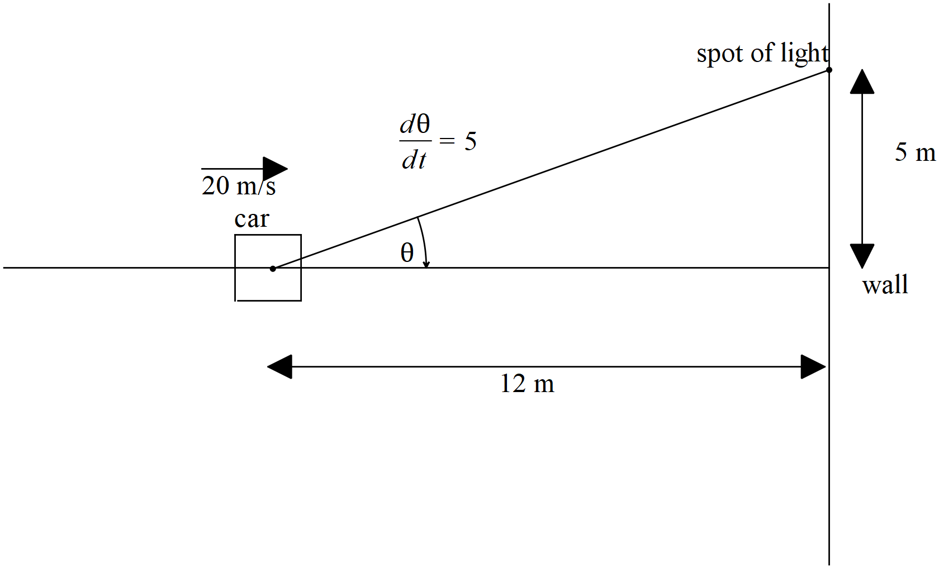

|  |
| --- |
| **Solution** |
| Also accept -78.75m/s if they have used negative angle rate! |
| **Specific behaviours** |
| 🗸 uses a tangent function  🗸 uses product rule  🗸 diffs tangent function correctly  🗸 uses correct rates  🗸 determines approx. speed |

**Investigation section.**

Q1 (3, 3, 4 & 4 = 14 marks)

Differentiate the following using logarithmic differentiation. Show all steps in this method.

1. 

|  |
| --- |
| **Solution** |
|  |
| **Specific behaviours** |
| 🗸 uses log laws  🗸 uses implicit diff  🗸 obtains derivative in terms of x and y |

1. 

|  |
| --- |
| **Solution** |
|  |
| **Specific behaviours** |
| 🗸 uses log laws  🗸 uses implicit diff  🗸 obtains derivative in terms of x and y |

1. 

|  |
| --- |
| **Solution** |
|  |
| **Specific behaviours** |
| 🗸 takes log of both sides  🗸 uses log law  🗸 diff both sides  🗸 obtains expression for diff |

1. 

|  |
| --- |
| **Solution** |
|  |
| **Specific behaviours** |
| 🗸 takes log of both sides  🗸 uses log law  🗸 diff both sides  🗸 obtains expression for diff ( no need to simplify tanx term) |